
Hans Raj MahilaMahaVidyalaya, Jalandhar

7.1.2

Alternate sources of energy

and

Energy conservation measures

GEO-TAGGED PHOTOGRAPHS

- Geo-tagged Photographs

ALTERNATE SOURCES OF ENERGY | WEBSITE LINK
Solar Energy | https://www.hrmmv.org/solarplant.php
Biogas Plant | https://www.hrmmv.org/biogas.php
Use of LED | https://www.hrmmv.org/led.php
Use of Power Efficient Equipment | https://www.hrmmv.org/power.php

7.1.2 Environment Consciousness and Sustainability: Alternate sources of energy
Facility | Photograph
1. Solar Energy | 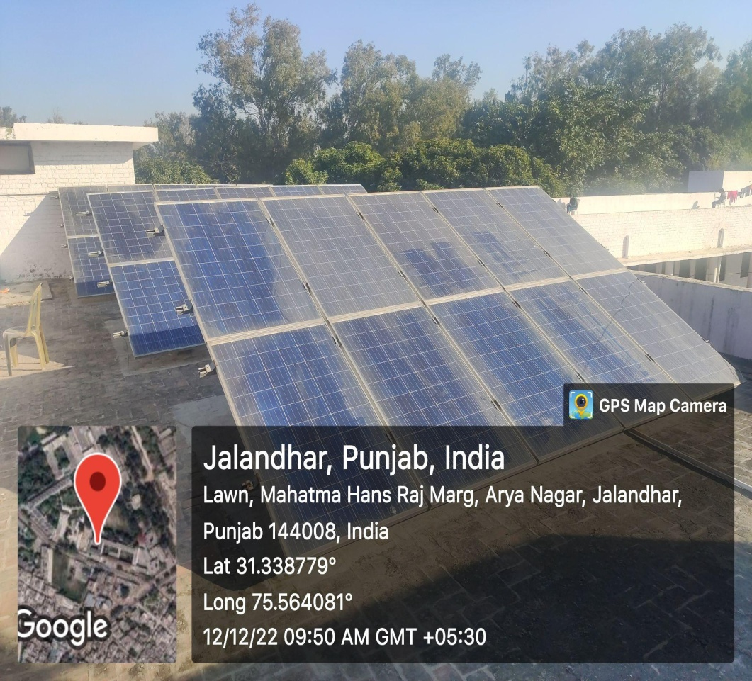  https://www.hrmmv.org/solarplant.php
2. Biogas Plant | 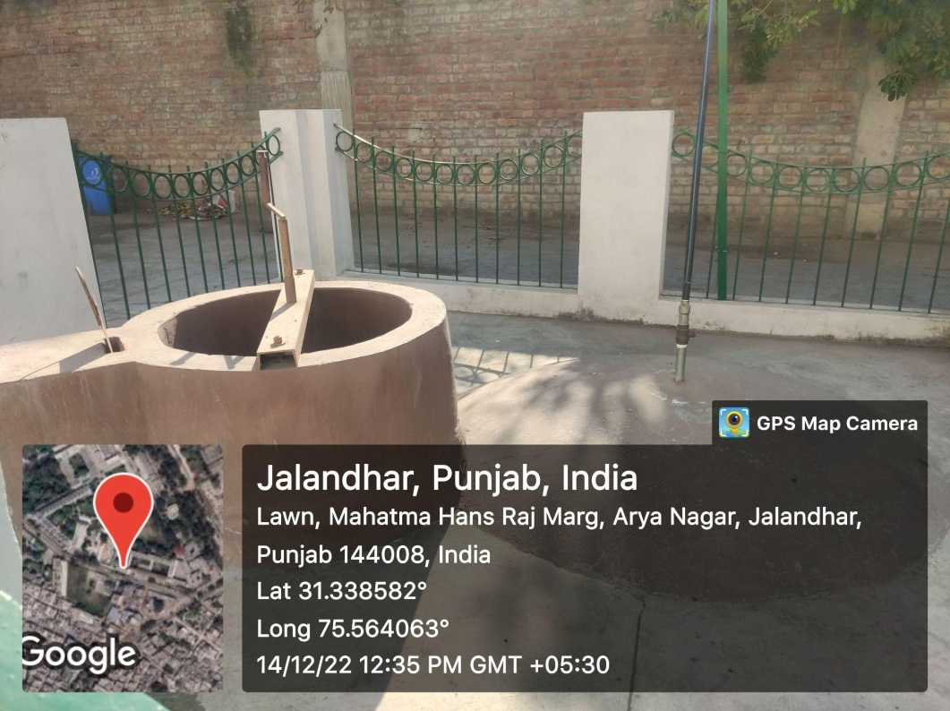  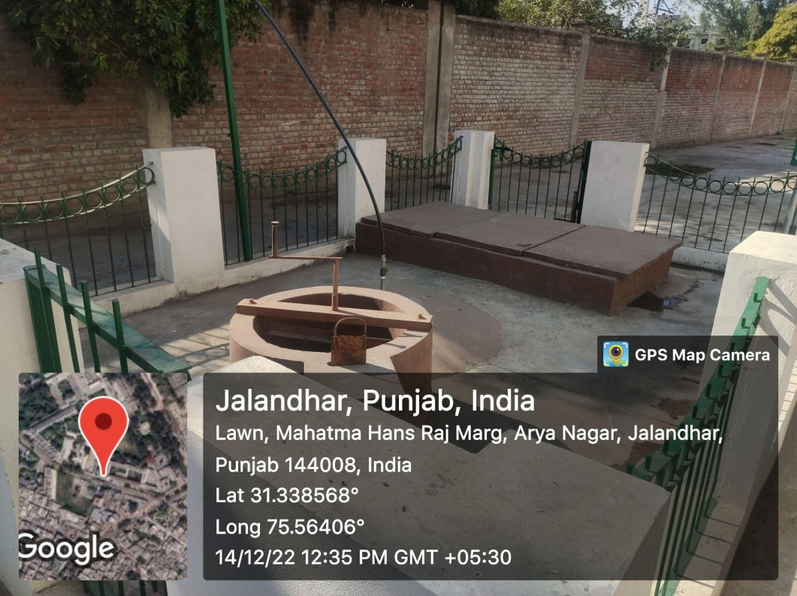  https://www.hrmmv.org/biogas.php
3. Wheeling to the Grid | https://drive.google.com/file/d/1MAzeOqDDYPWjPqZsWLebFK7is5dlCh60/view?usp=drive_link
4.Use of LED Bulbs | 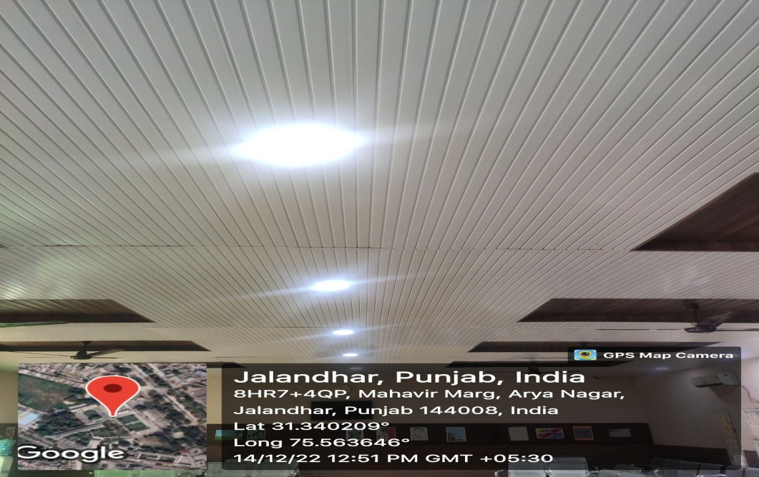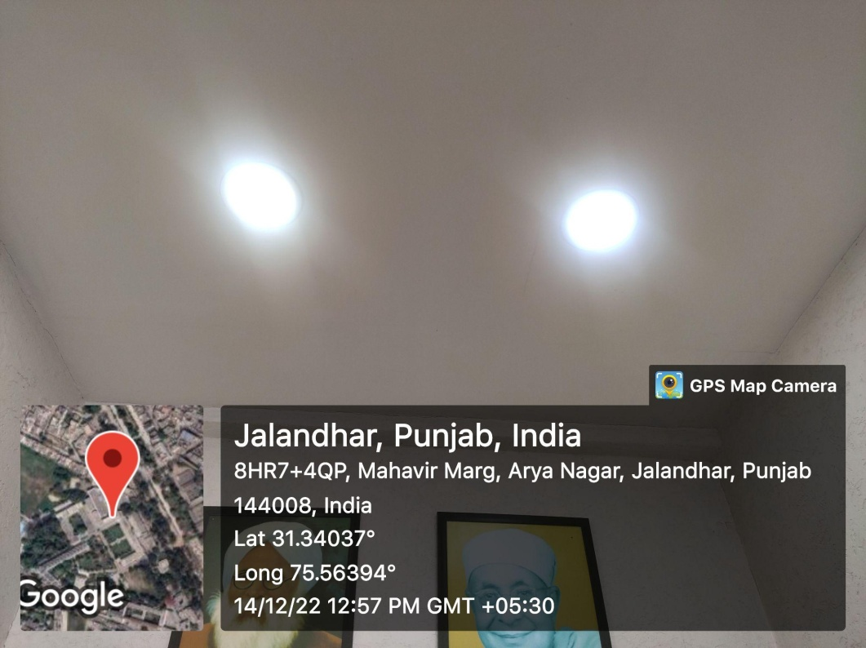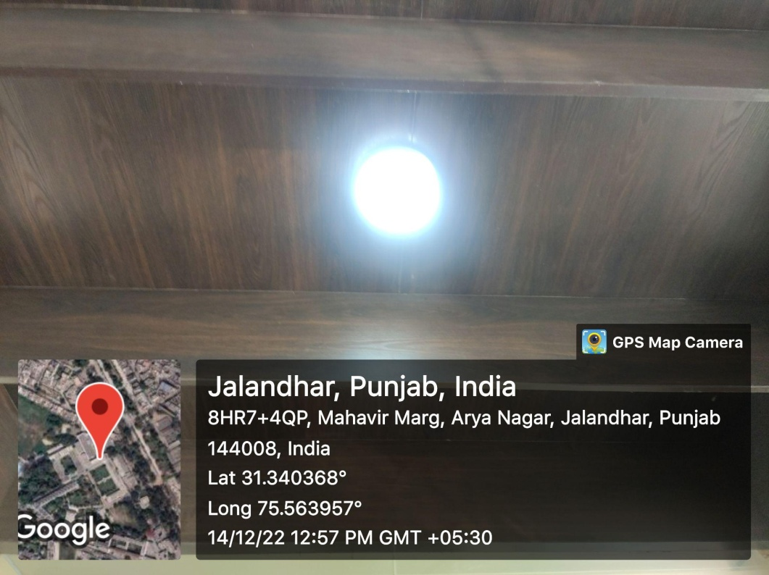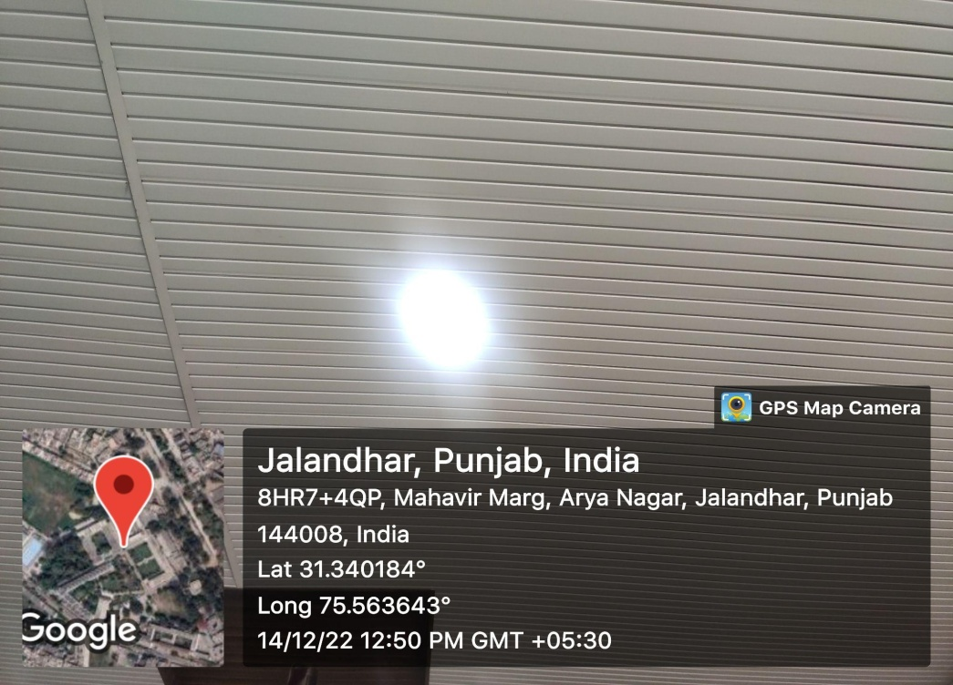
Use of power efficient equipment | 